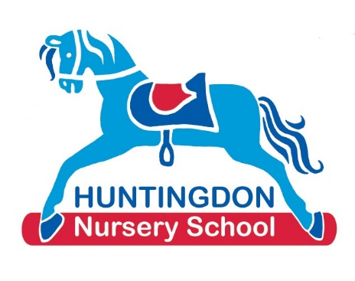

Our Curriculum

We follow the statutory Early Years Foundation Stage Framework as our key document for children’s learning whilst at Huntingdon Nursery School. Alongside this we also use the non-statutory guidance Development Matters and Birth to Five Matters. Please see links to all three of these documents below to learn more about them. Please also read our Curriculum statement

Early Years Foundation Stage Framework
https://www.gov.uk/government/publications/early-years-foundation-stage-framework--2

Development Matters
https://www.gov.uk/government/publications/development-matters--2

Birth to Five
https://www.birthto5matters.org.uk/

The Early Years Foundation Stage framework covers seven areas of learning the first three, known as the Prime areas, are Communication and Language, Personal Social and Emotional Development and Physical Development. The remaining four, known as the Specific areas, are Literacy, Mathematics, Understanding the World and Expressive Arts and Design. In reality these different areas overlap.

We focus not only on what children are learning but how they are learning and developing.
This involves a focus on what are known as The Characteristics of Effective Learning. These characteristics focus on how children learn through playing and exploring, become active learners by following their own interests and making their own choices, and how they also become critical thinkers setting themselves their own challenges and solving the problems that they meet along the way.

We hope you enjoy looking at the photos below which will give you a little bit more understanding of how learning takes place at Huntingdon Nursery School.

Communication and Language

It is crucial that children learn both to express themselves and listen to others in order to be able to get on with each other. The adults at Huntingdon Nursery School spend a lot of the day engaging in conversation with children, extending and developing both their ideas and vocabulary and just enjoying a chat together. We also love sharing daily stories and enjoying rhymes and poems.

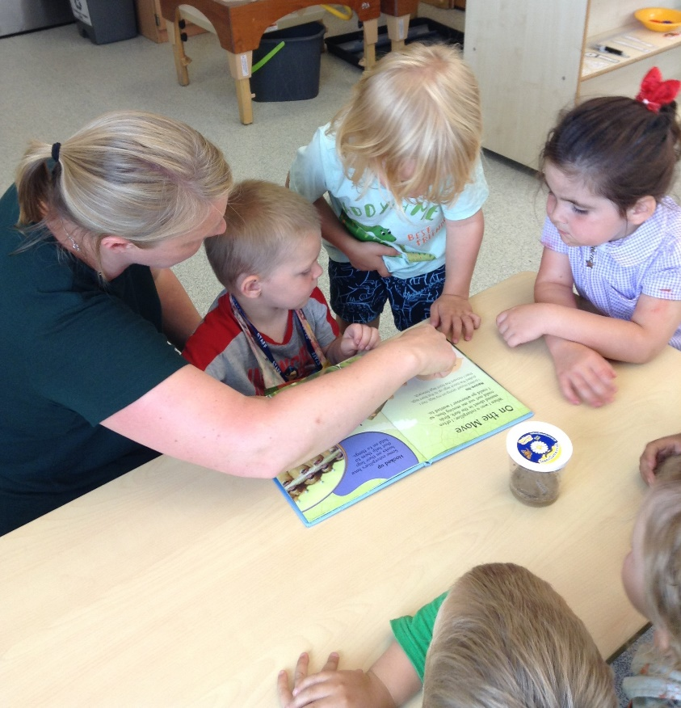

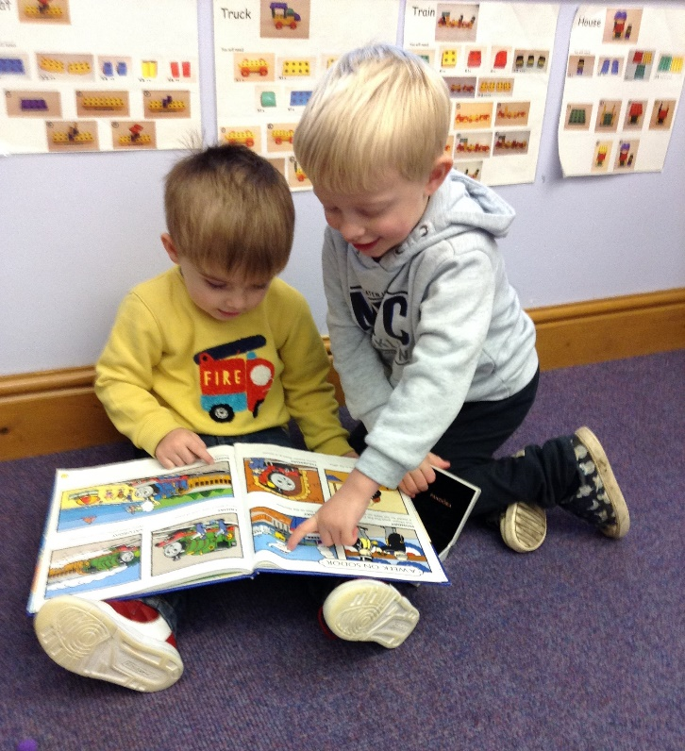

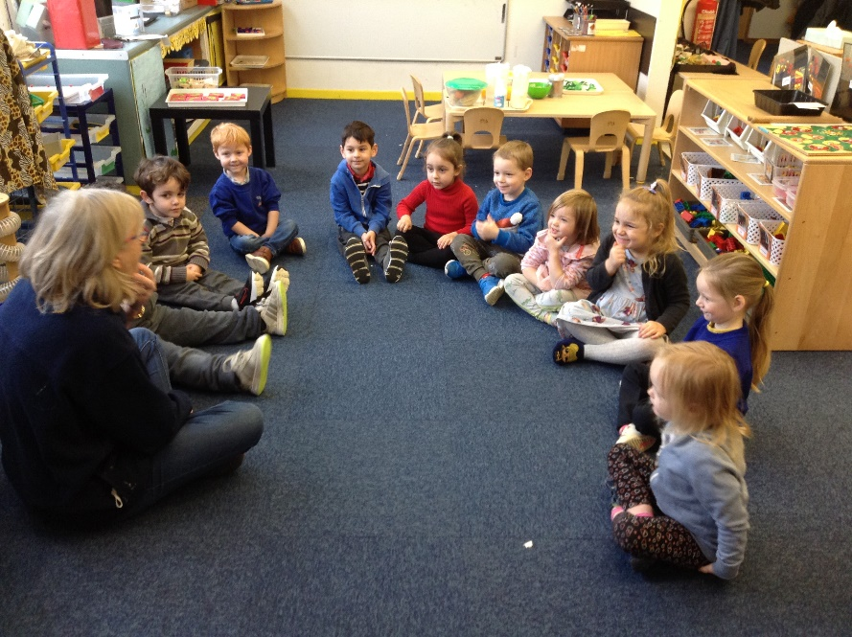

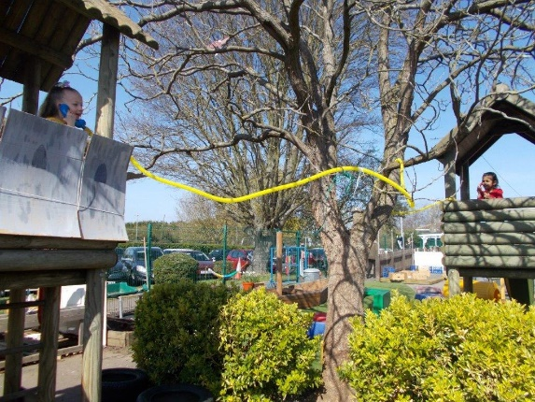
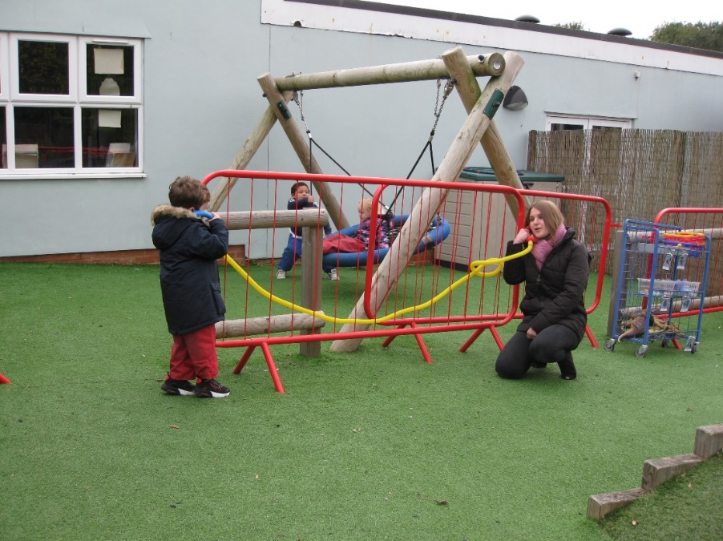

Personal Social and Emotional Development

This is a really crucial area for children as it focuses on understanding their own feelings and the feelings of others, as well as developing friendships, having fun and starting to become confident and happy in themselves. Adults spend a lot of time supporting and encouraging children to solve problems and learn to work and play happily together as a class group. These are all really valuable skills for life.

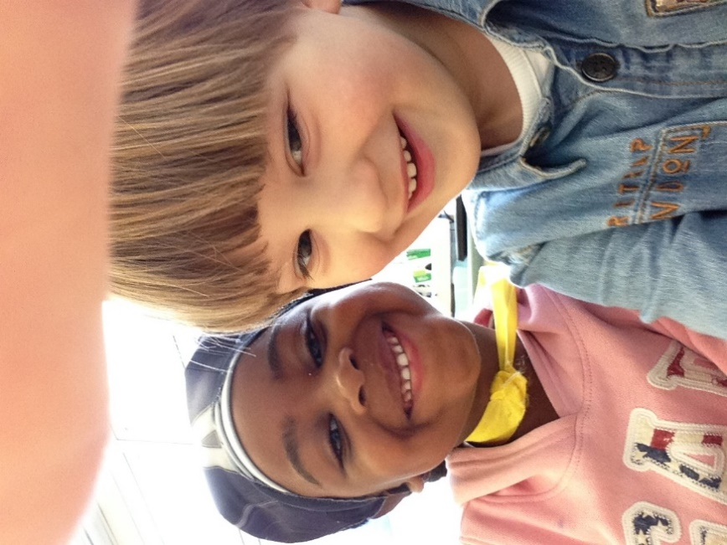

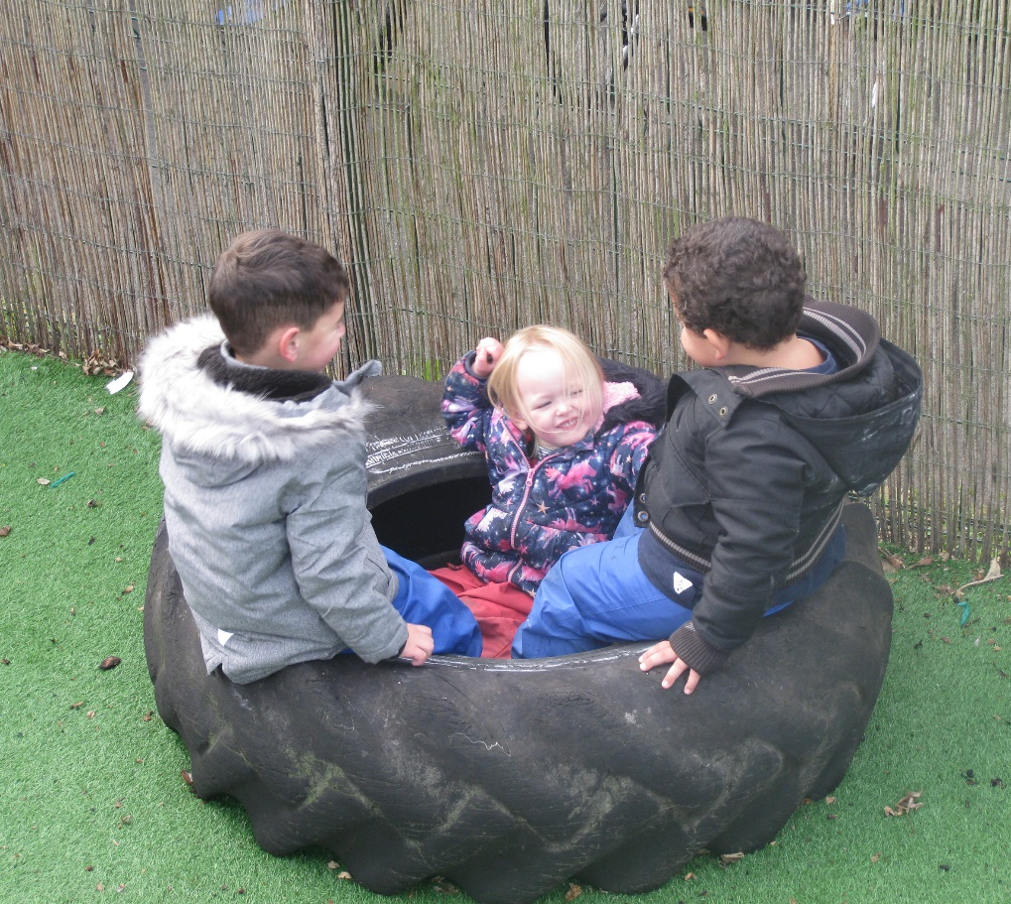

Taking selfies on the ipad

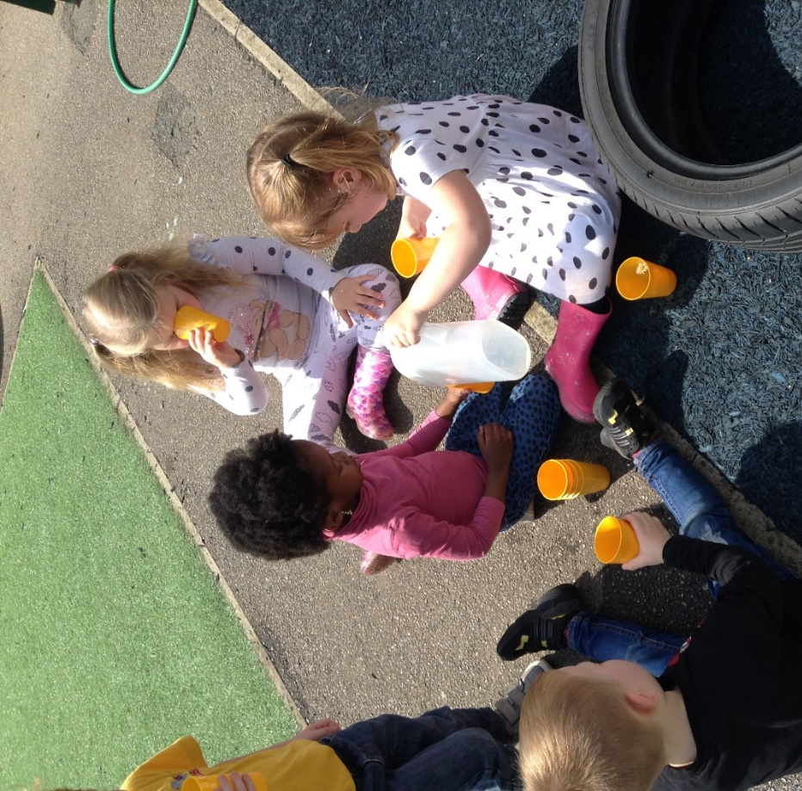

Playing together

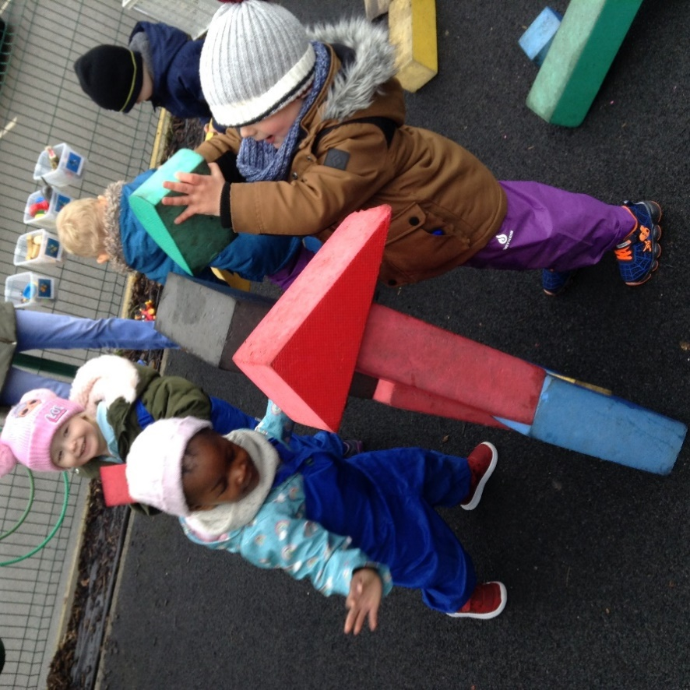

Helping a friend

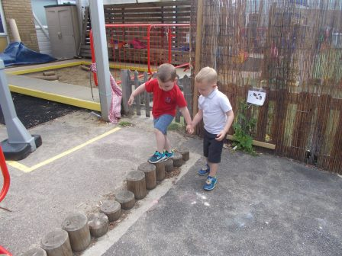

Physical Development

Physical Development focuses on keeping our bodies healthy so that we can lead happy and active lives both now and into the future. At Huntingdon Nursery School we focus on gross motor skills for example enjoying running, jumping, learning to climb safely as well as a big favourite digging in our sandpit! Fine motor activities include building with Duplo or Lego, painting and drawing, sewing and enjoying puzzles.

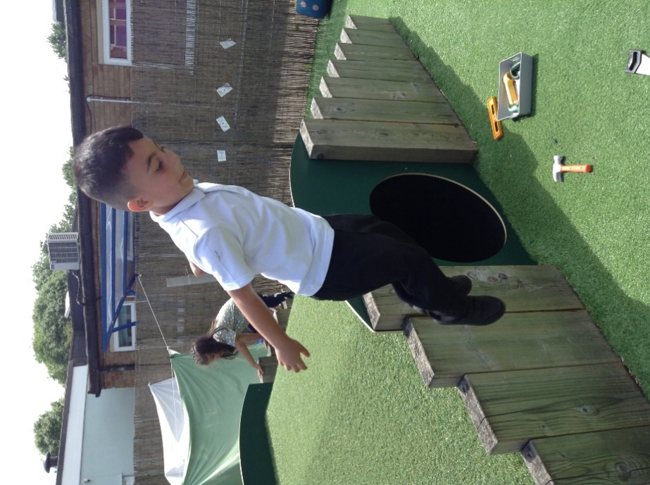
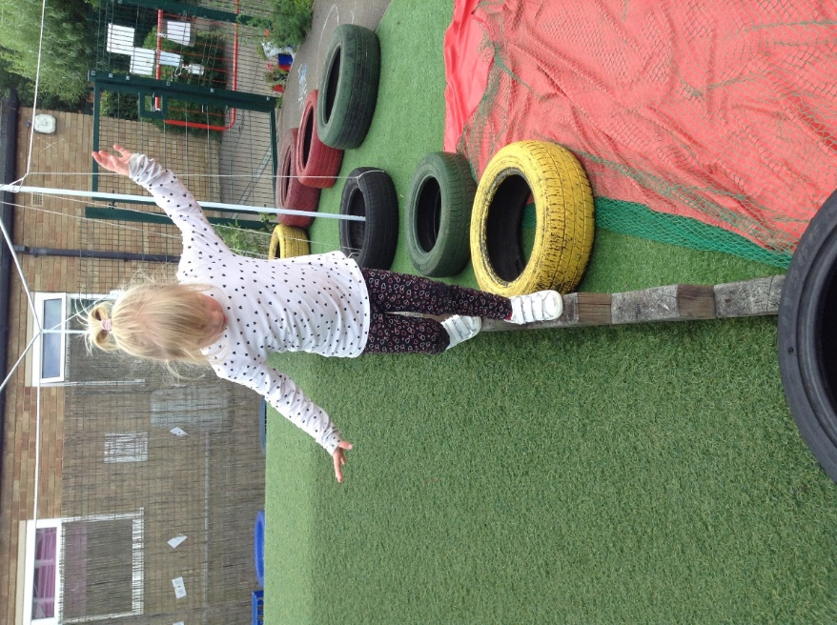
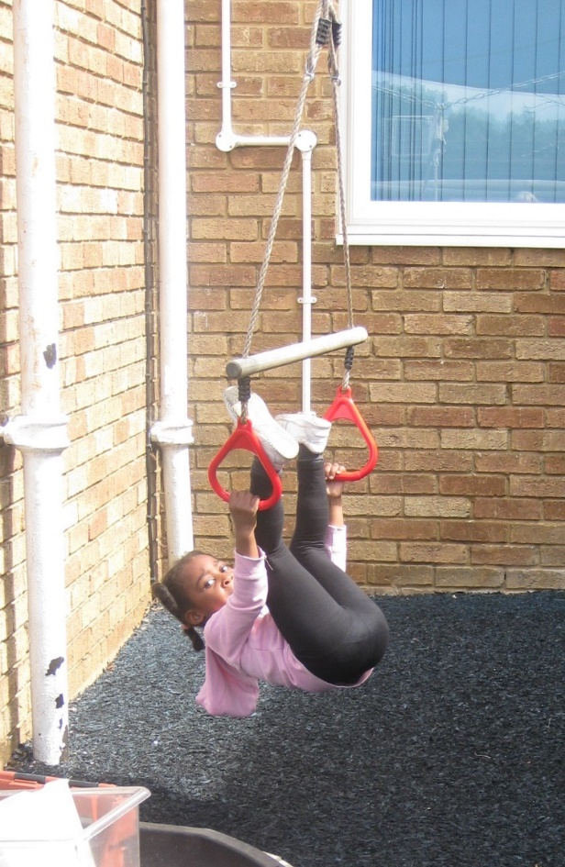
Hanging upside down, jumping and balancing.

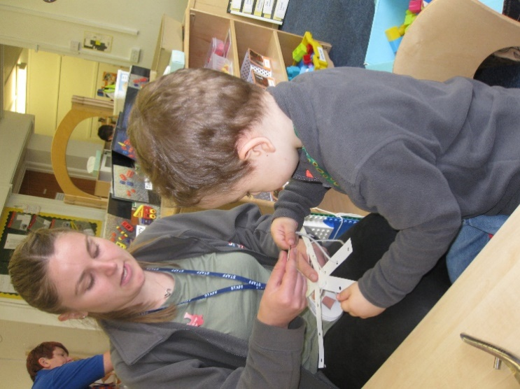
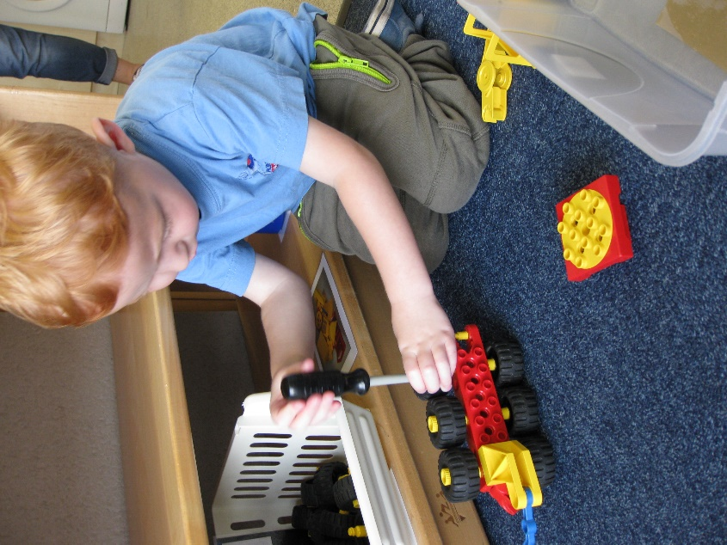

Using tools such as scissors and screwdrivers

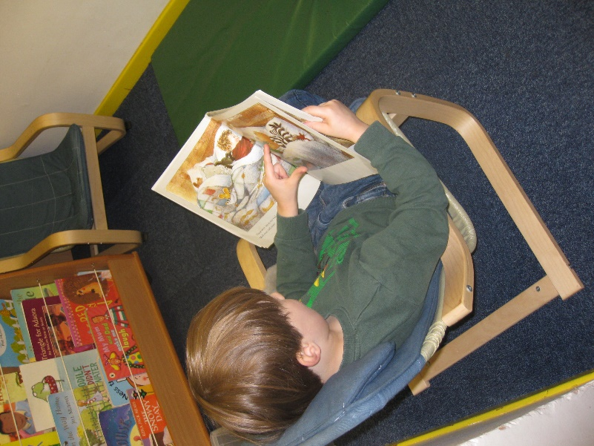
Literacy
At Huntingdon Nursery School children develop a real love of story and story-telling. This is done through adults sharing stories daily in our cosy sofa areas as well as at group times. We get to know some particular Core texts really well and often enjoy acting these out with story props, making story maps and even re-writing them with our own ideas. Alongside reading, writing also starts to develop. As children use their name cards they learn to recognise their individual names, that letters have a meaning and then start to copy these letters as they start to write their own names and other words.

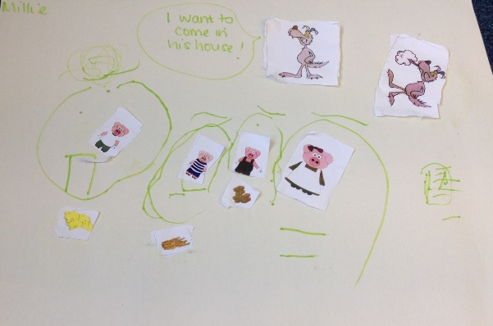
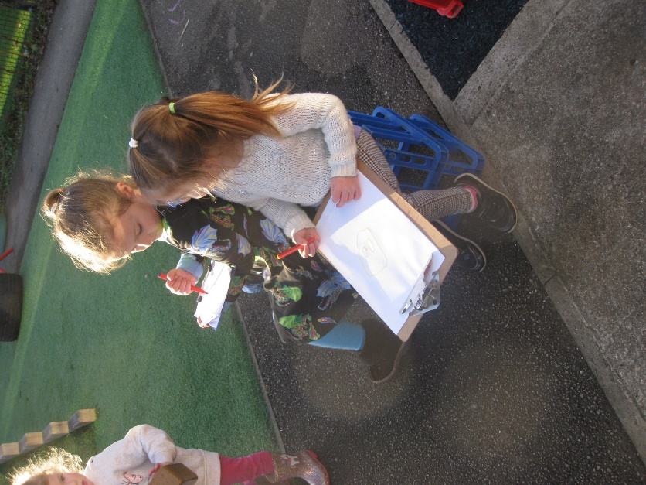

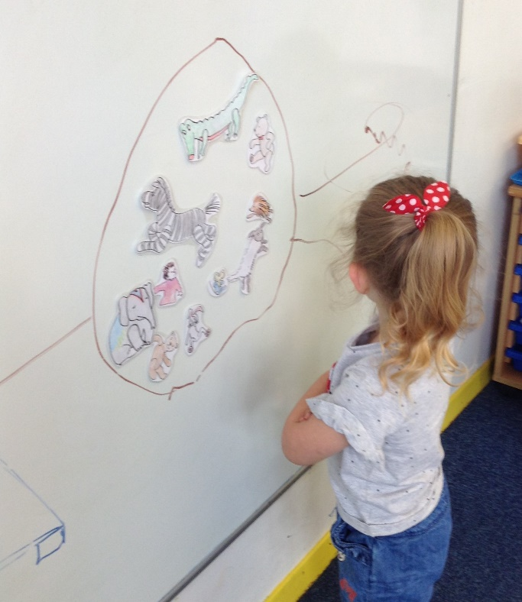
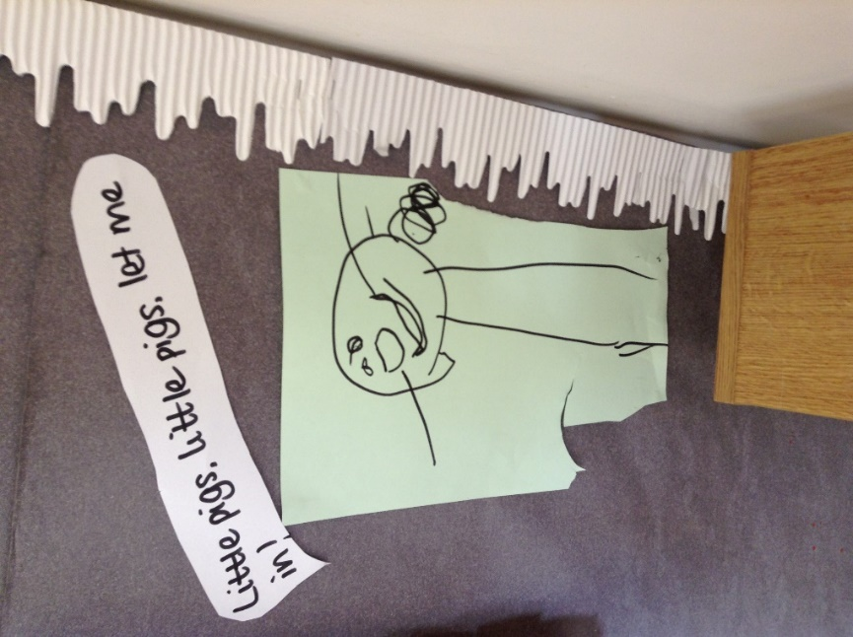

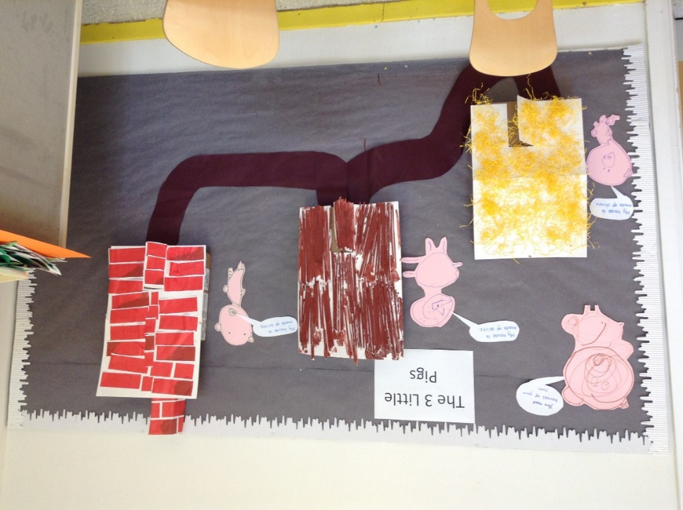

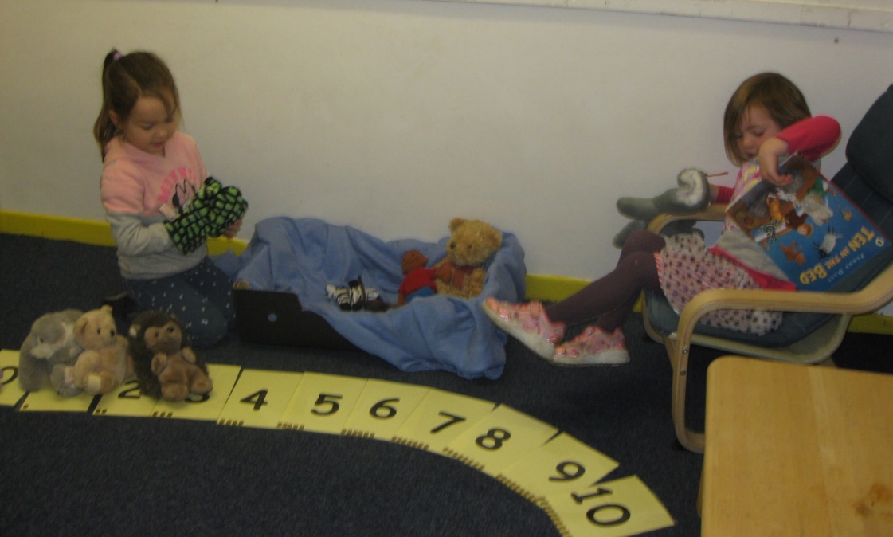

Mathematics

We teach maths through a range of everyday activities that involve all sorts of mathematical ideas such as grouping, comparing, counting, measuring and pattering.
Children are supported to develop their spatial skills as well as to develop a deep understanding of numbers and counting.
Activities might include arranging correct number of cups at snack time, counting the number of children in the class that day, or recognising patterns and shapes in our everyday environment. Our aim is that all children will become confident enthusiastic mathematicians for life.

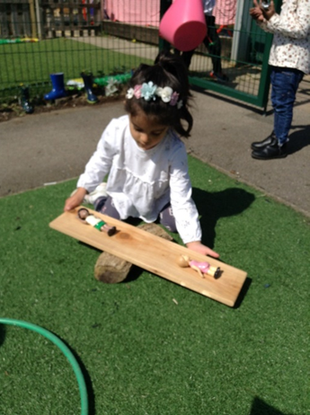
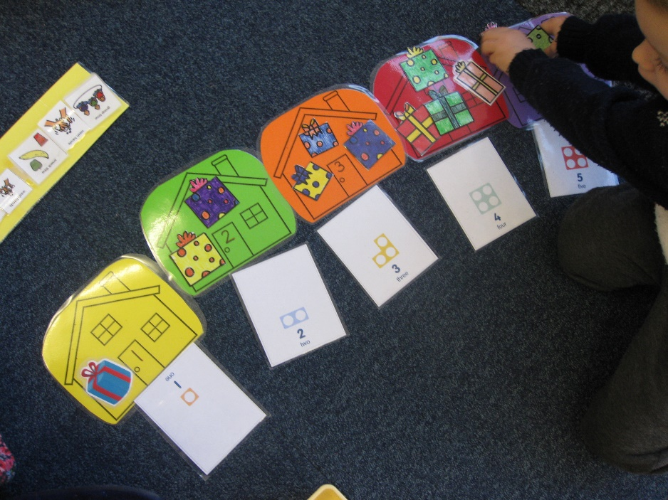

Counting

Balancing

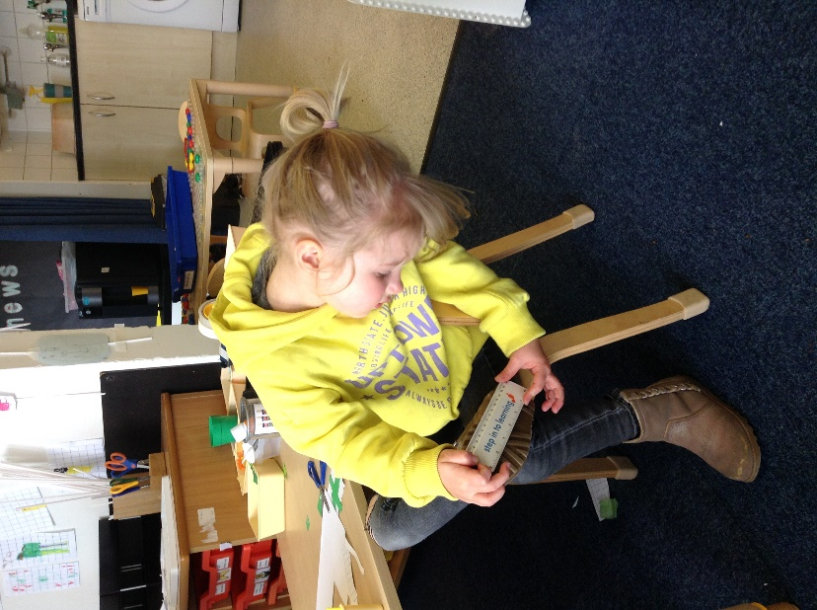
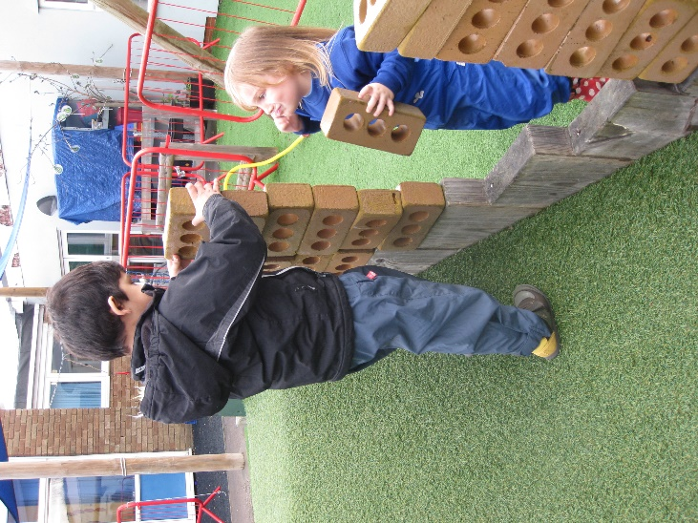
Organising and sequencing
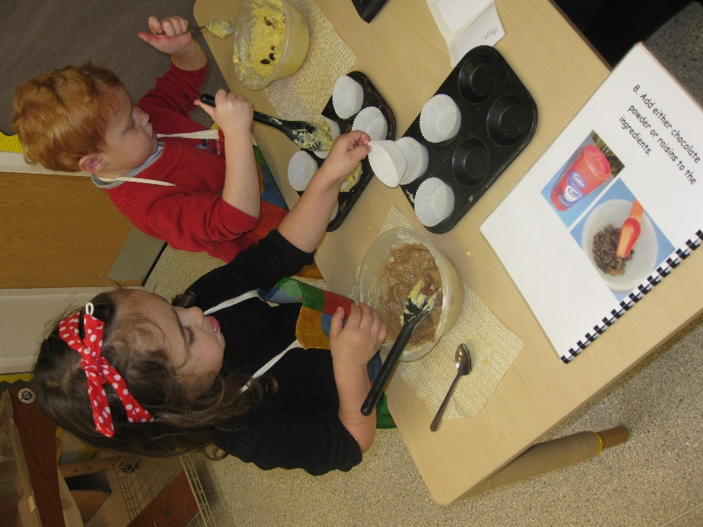

Arranging
Measuring

Understanding the World
At Huntingdon Nursery School we encourage children to learn not only about their own families and community but the varied and different worlds of their friends. We like to invite parents into Nursery to share their particular skills or knowledge about special festivals or traditions for themselves and their families. We are also passionate about children developing a love and understanding of the natural world around them which is going to be so vital for their futures. We are very lucky to have so much easily accessible outdoor space which allows the children to experience and learn about the seasons. Each class enjoys experiencing a range of planting and growing from salad leaves, broad beans, tomatoes, potatoes to sunflowers and nasturtiums. It is through these activities that children can learn all about growing their own food and then enjoy making something delicious to eat together back in the classroom.

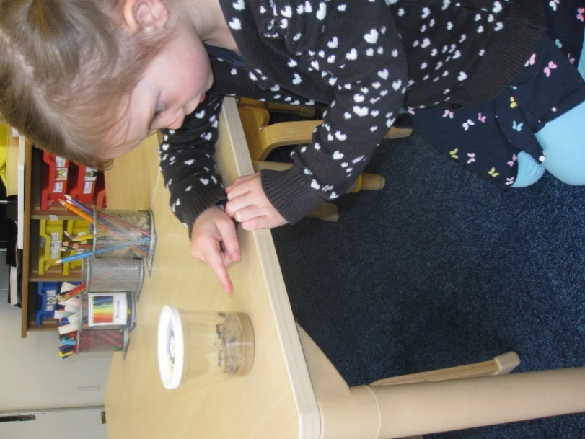

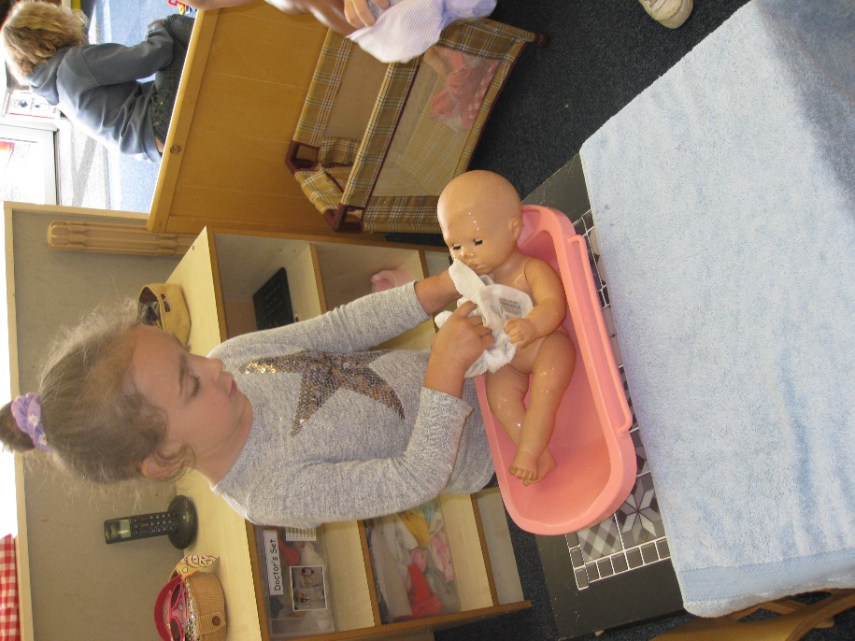

Watching the change form caterpillar to butterfly

Rehearsing experiences from home such as bathing the baby.

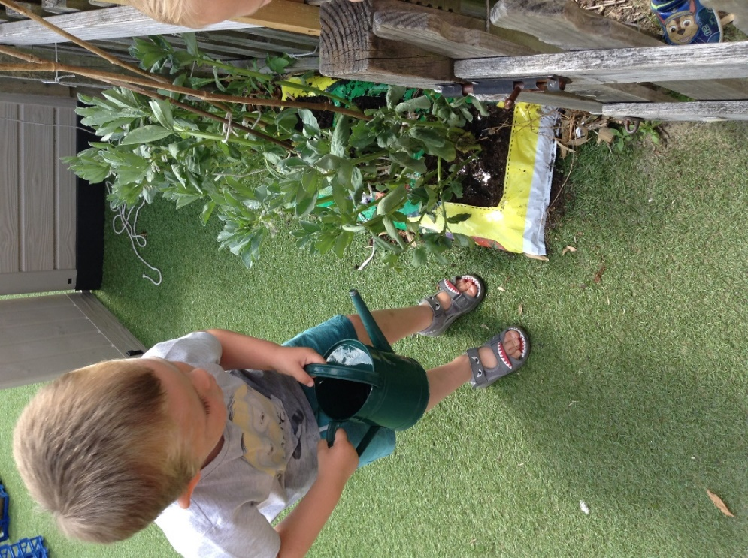

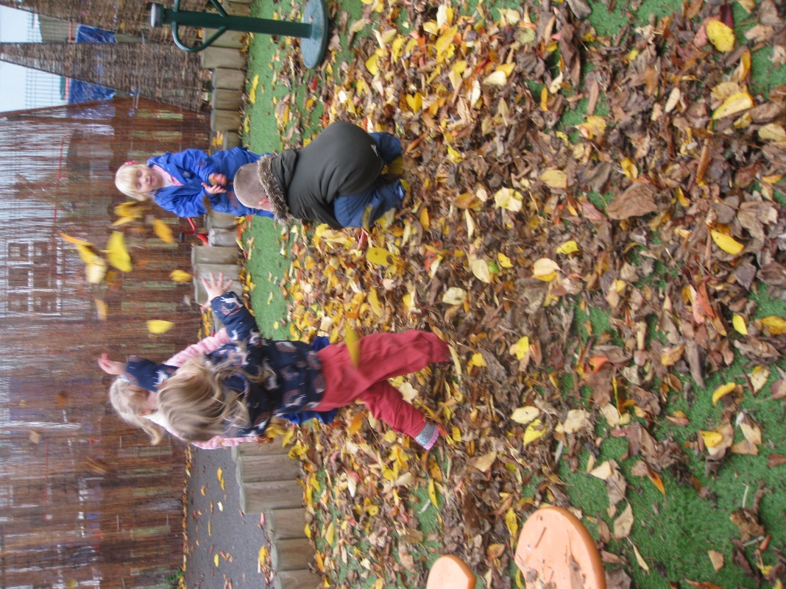
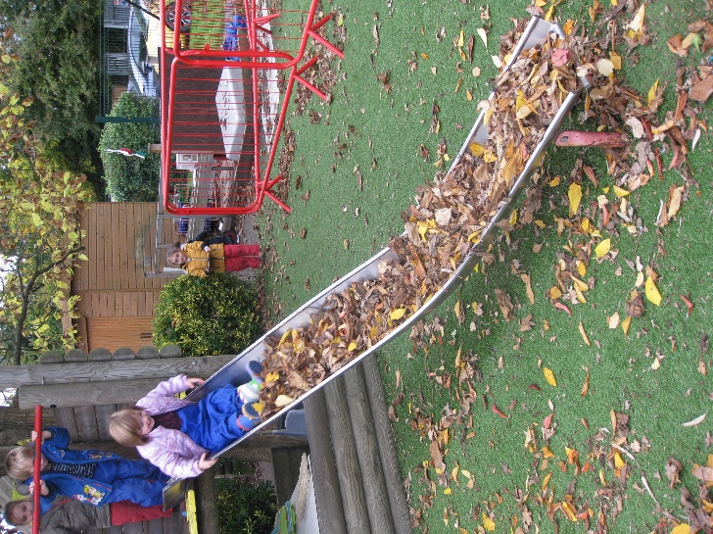

Taking care of the broad beans

Experiencing Autumn!

Expressive Arts and Design
Children have lots of opportunity to be creative and express their creativity through painting drawing, sticking, model making, music, dancing and imaginative play. They are also encouraged to tell their own stories and have fun acting these out with their friends taking on the parts or use the range of small world figures in each classroom.
Music and singing make up an important part of our sessions.

